B01_1
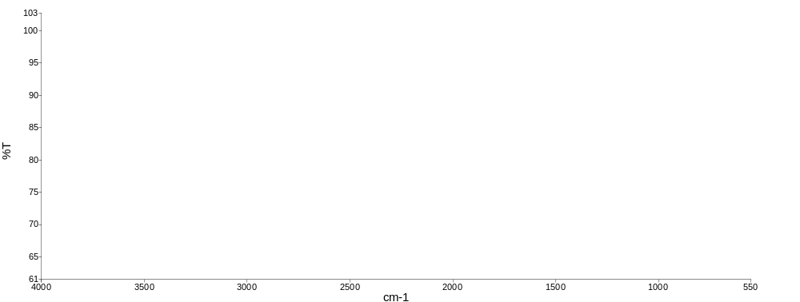

Sample Name | Description | Saved or unsaved State | Spectrum quality check summary
B01_1 | Sample 010 By User 1 Date Monday, December 15 2025 | Not saved | The Quality Checks give rise to a High Noise warning for the sample.

B01_1
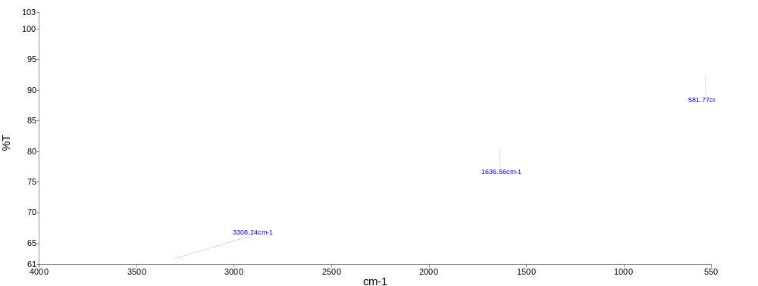

Sample Name | Description | Saved or unsaved State | Spectrum quality check summary
B01_1 | Sample 010 By User 1 Date Monday, December 15 2025 | Not saved | The Quality Checks give rise to a High Noise warning for the sample.

B04_1
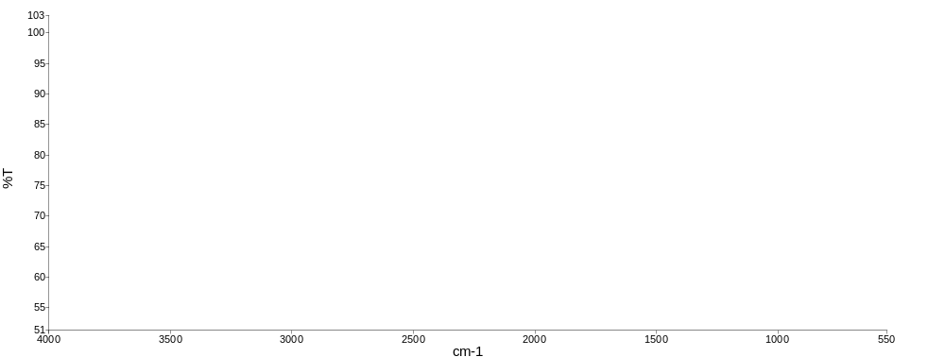

Sample Name | Description | Saved or unsaved State | Spectrum quality check summary
B04_1 | Sample 011 By User 1 Date Monday, December 15 2025 | Not saved | The Quality Checks give rise to a High Noise warning for the sample.

B04_1
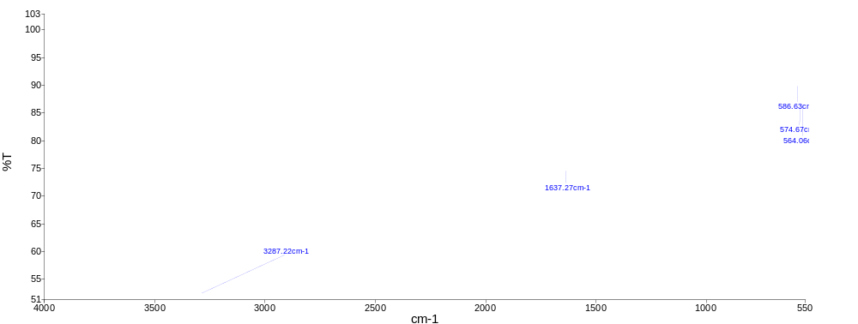

Sample Name | Description | Saved or unsaved State | Spectrum quality check summary
B04_1 | Sample 011 By User 1 Date Monday, December 15 2025 | Not saved | The Quality Checks give rise to a High Noise warning for the sample.

PVC
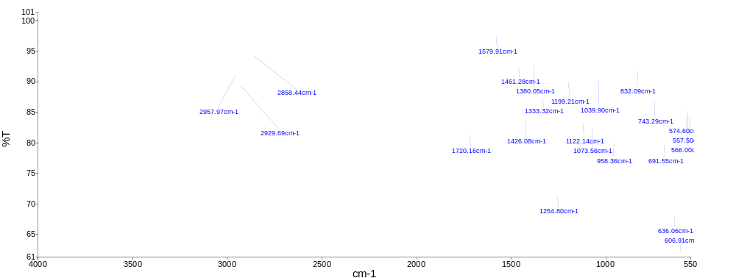

Sample Name | Description | Saved or unsaved State | Spectrum quality check summary
PVC | Sample 011 By User 1 Date Monday, June 30 2025 | Saved | The Quality Checks give rise to a Weak Bands warning for the sample.

PVC Search Result

User 1
Monday, 15 December, 2025

Index | Sample Name | Search Best Hit | Search Best Hit Description
1 | PVC | AP0072 | POLY(VINYL ALCOHOL) 88% HYDROLYZED

List of Searched Library References

Search Score | Library Reference | Search Reference Spectrum Description | Search Library
0.6531 | AP0072 | POLY(VINYL ALCOHOL) 88% HYDROLYZED | polyatr
0.632561 | F80102 | DIBUTYL PHTHALATE | FLUKA
0.629686 | AP0046 | POLY(DIALLYL PHTHALATE) | polyatr
0.608106 | AP0044 | POLY (1,4-CYCLOHEXANEDIMETHYLENE TEREPHTHALATE) | polyatr
0.560684 | F81910 | PROPIONIC ACID | FLUKA
0.547245 | AP0041 | POLY(BUTYL METHACRYLATE) | polyatr
0.542518 | AP0096 | VINYL CHLORIDE/VINYL ACETATE/VINYL ALCOHOL 80% VC, 14% VINYL | polyatr
0.541812 | AP0075 | POLY(VINYL CHLORIDE), CARBOXYLATED 1.8% CARBOXYLATED | polyatr
0.536449 | F80072 | BIS (3,5,5-TRIMETHYL HEXYL) PHTHALATE | FLUKA
0.514164 | AP0057 | POLY(ETHYLENE TEREPHTHALATE) | polyatr

Spectra

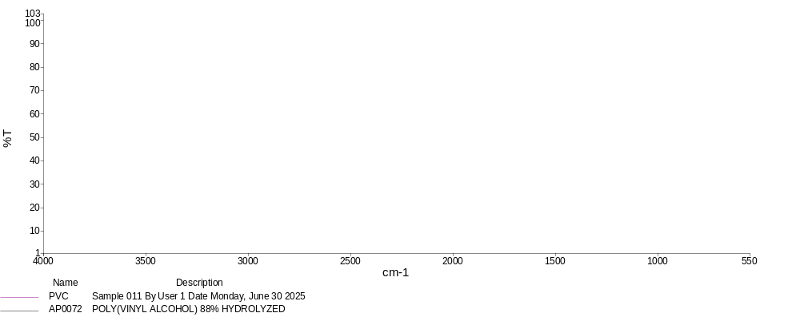
Samples View 1
